Does Political Activity on Social Media Have an Effect on Younger Voters?
By Taylor Carson and Cody Nespor Slippery Rock University 5-2-16

Table of Contents:
Abstract ………………………………………………….. 2
Introduction ……………………………………………… 2-3 Justification ……………………………………………… 3
Review of Literature …………………………………….. 3-13
Research Methods ……………………………………… 13 Data Analysis …………………………………………... 13-17
Conclusion ……………………………………………... 17-19
Works Cited ……………………………………………. 20-21
Appendix ……………………………………………….. 22-39

Research Proposal
Abstract:
The use of the internet in political campaigns has been shown to be a powerful force in generating support for candidates in recent years. Furthermore, the influence of political activity on social media has become even more apparent in the 2016 United States Presidential election. A survey was conducted in order to find a connection between a voter’s political and social media activity. Ninety-one surveys were collected incorporating eight questions about the respondents’ social media habits and political activity. The findings concluded that there is a positive correlation between social media usage and political activity. Additional investigation resulted in evidence of discrepancies between the two major political parties.
Introduction:
Social media interaction has recently become a driving force in political campaigning. Candidates gravitate to social networking sites (SNS) to attract young voters, gain political influence/ appeal, and stay in contact with constituents. The constant connection America’s youth maintains with the online world provides candidates with a powerful platform to rally supporters and captivate attention. Social media has proven to be an especially powerful force in the 2016 presidential election. This elevates the importance of studying the influence political activity via social media has on youth voters. In particular, this study focuses on the impact such political activity has on the levels in which young voters act with political efficacy. Research involved surveys being distributed to students on the campus of Slippery Rock University of Pennsylvania. Additionally, the online survey was hosted on surveymonkey.com questioning participants on their social media use, participation in political activity, and how such participation changed their knowledge/ view of said politics. The data from this study was applied to determining how social media interaction impacts political activity, efficacy and participation.

Justification:
This research will be useful for communication experts, political analysts, youth voters, and politicians alike. Voters will know what to consider when observing political activity on social media. Meanwhile, politicians will better understand what to broadcast and how to use social networking to an advantage. Political analysts, in turn, will be able to analyze how current and future political candidates use or fail to use SNS to generate support for their campaigns and the politicians’ positive or negative social media influence. Finally, communication experts can use the research to study social media interaction and its link to political activity in adolescent voters. In general, this study will provide people with a better understanding of social media activity and political influence, and establish the relationship between said activity and its effect on youth voters.
Review of Literature:
Social media has been the subject of both positive and negative attention from communication experts. Much of what is discussed in relation to social media is whether SNS enhances communication by breaching distance, or hinders it by distracting from face-to-face interaction. However, social media has been perceived as a way to stimulate political activity and efficacy amongst young voters. These young voters, typically uninclined to participate in politics, grew notably engaged with President Obama’s social media campaigning.
A number of studies have been implemented since the president’s campaign and corresponding election. Dr. Tanja Storsul is the head of the Department of Media and Communication at the University of Oslo. In a study Dr. Storsul conducted, a focus group of Norwegian teenagers (between the ages of sixteen and nineteen) were interviewed about social media as a medium for political activity. Storsul (2014) stated in the article that on social media, ordinary people can communicate directly with authorities, and with each other (p. 21). This distinction suggested an inclusiveness that other political outreach methods could not mimic. The idea Storsul referred to in this statement is deliberation. The openness to political deliberation on social media could be perceived as a means to incorporate people of many different backgrounds simultaneously.
Deliberation, however, is not the only element Storsul focused on within this study. Participatory democracy is a term frequently referenced in the article. There are vast amounts of public opportunities for expression available on SNS Political candidates and voters alike can broadcast opinions in subtle, moderate, or grand ways. Storsul (2014) explained that in some instances this is accentuated by using the profile picture to underline views. For example, some informants tell about how they participated in campaigns against child abuse by using a picture of their favorite cartoon as their profile picture (p. 23). This show of support is not extreme or directly written out, yet it relays a message nonetheless. Participation methods such as this were popular amongst those being interviewed in the study. As such, participatory democracy is influenced by another element studied in Storsul’s work.
Self-presentation is also an important element considered in Storsul’s article. In all the focus groups, the informants explained that they evaluated their Facebook friends and how they appeared, and they were greatly aware of how they presented themselves (Storsul, 2014; 24). Reputation on social media can mean a lot to young people. This influences how willing young voters are to share support for or follow campaigns directly on social media. A fear of judgment can dissuade the youth from participating in a meaningful or apparent fashion. Despite this, this is only one hindrance to social media’s influence on youth political activity. Participatory democracy and deliberation are upstanding factors in the measure of social media’s influence.
Storsul’s study and article explain that social media has positive and negative effects on political activity in young voters. The positive effects, however, provide meaningful opportunities for both candidates and voters. It is apparent that politically engaged young people in Norway use social media for political purposes shows that social media have become important instruments for political participation (Storsul, 2014; 26). Social media was a very prominent tool for political participation amongst these young people. As a result, many politicians would want to use this evidence as an advantage in the electoral process.
Assistant professor at Bloomsburg University, Chang Sup Park conducted a study in which he set out to determine whether Facebook or Twitter prompted more political interactions. Park looked at what motivates people to use the different SNS and determined that People use Facebook more for “social connection, shared identities, content, social investigation, social network surfing, and status updating” and Twitter was used more “as an information source, rather than as a tool for satisfying social needs,” (2015). Park summarizes that when people use Facebook for social interaction they are looking for a sense of belong and so people are more likely to seek out views similar to their own. In contrast, people use Twitter as an information source and thus, seek out viewpoints that differ from their own. With this in mind, Park concludes that Twitter is a better medium for political interactions as the interactions are generally between people with opposing views, whereas interactions on Facebook are generally between like-minded individuals.
A study by Chia-Shin Lin looked at how political activity occurred during the 2012 Presidential election in Taiwan on Facebook. Lin suggests that information on Facebook is shared through a two-step flow model, in which opinion leaders act as information sources and diffuse information to the public. The opinion leaders in this model are political officials and their parties. Lin comments that this type of interaction opposes what Facebook is commonly used for. “(The) presidential election had little in common with social media friendships, in which users share their ideas, share opinions and construct networks,” (2015). Lin argues that Facebook is used as a medium to interact with friends and political leaders and parties on the SNS are only able to act as “para-social relationships” where only one side, in this case the political leaders, interacts with the other, the public. Lin argues that because of this, political activity on Facebook acts as more personalized interactions than other SNS. In the end, Lin concluded that candidates that were able to capitalize on this more personal medium and attract the largest following on Facebook were the most successful in the election.
Political efficacy is not limited to the individual. An article by Alcides Velasquez and Robert LaRose detailed the importance of considering external and internal political efficacy in relation to social media. A collective group’s influence could differ substantially from that of an individual’s. By taking both forms of political efficacy into account, a study could provide better results. This concept was applied to Alcides Velasquez and Robert LaRose’s study. A sample of politically active college students from a university in the Midwestern U.S. were given a survey questionnaire.
From this survey, Velasquez and LaRose (2015) found support for an SCT model in which SNS use enhanced perceptions of political learning efficacy through the four sources of efficacy perceptions. Political learning efficacy predicted political knowledge, which in its turn was an antecedent of internal political efficacy (p.901). This resulted in finding evidence that confirms that internal political efficacy is a positive predictor of political participation.
Meanwhile, collective political efficacy was tested as well. A positive connection was found between the sample’s participation in collective political efficacy and online political activism. This connection, however, varied based on the apparent interdependence of the presented tasks. A perception of interdependence on others and others on themselves provided for a stronger relationship between collective political efficacy and online political activism. Group environments were very influential to this study.
Velasquez and LaRose provided political participation and social media activity research with powerful new components to consider. As political uses of social media become more popular among youth an understanding of the factors related with their online collective activism becomes more relevant (Velasquez and LaRose, 2015; 913). Social media has become a regular part of adolescent life. There has been a shift of attention from former methods of political activism, to political activism in connection with social media. This mobilization of participation has a powerful effect on adolescents, but a distinguishable normalizing effect on the adult voting population. The power social media has in relation to political participation revolutionizes the way youth voters view politics.
A study by Xabier Martinez-Rolan and Teresa Pineiro-Otero determined what kind of activities on social media are most effective. Martinez-Rolan is an instructor at the University of Vigo in Spain and Pineiro-Otero is a lecturer at the University of A Coruna, also in Spain. These two studied the use of memes on Twitter by Spanish political parties and leaders during the 2015 State of the Nation Debate. They followed all the tweets that used the hashtag #DEN2015 and analyzed the content of the tweets to try and determine which kinds of tweets generated the most interactions with the public. Martinez-Rolan and Pinerio-Otero thought that memes would be able to engage more people on Twitter due to their simplicity and how people are able to interact with them. “The digital essence of these memes, their potential virality and their capacity to create new content or remixes, generate a chain of creative feedback. This is a new language that allows for the maximum communicative potential using visual and simple content,” (Martinez-Rolan & Pineiro-Otero, 2016). Through using social media activities that youth voters are familiar with, such as memes, political parties and leaders are able to create more interest with those youth voters via this familiar medium.
Candidates have noticed the power social media holds in elections. As such, an increasing amount of candidates have developed social media presences to connect to young voters. This draws particular attention to the impact SNS have on youth participation in elections and politics. Delia Dumitrica of Saint Louis University, took notice of the potential impact and chose to study it more closely. The focus of Dumitrica’s (2016) attention was a case study on the 2010 mayoral race in Calgary, Canada, in which an independent and virtually unknown candidate rose to fame and won the mayoral seat in what appeared to be a social media–led electoral campaign (p. 35). This candidate utilized the connection between political involvement, and the online political involvement presented predominantly by today’s youth. Social media, after all, acts as a means of political participation, as well as an opportunity for political discussion. Dumitrica argues that the very definition of political activity needs to be adapted in order to accurately include SNS. “In the tradition of political communication, engagement is often a priori defined as consisting of a limited set of actions through which citizens seek to influence the course of politics,” (2016). Dumitrica argues that political activity on SNS need to instead be evaluated on factors such as political knowledge, discussion and political engagement off-line, among other things.
In 2010 Dumitricia examined 59 University of Calgary undergraduates and their political engagement on Facebook and Twitter in regards to the 2010 mayoral elections. This research determined that youth involvement prior to the 2010 election was low and that adolescents’ inactivity did not come from indifference, but rather a failure of candidates to engage them. Dumitricia concluded that youth voters prefer more individualized political engagement and candidates that are able to provide this kind of political engagement are more successful. The result of this study was that the eventual winner of the election, Naheed Nanshi, had best made use of SNS and a direct relationship was drawn between Nanshi’s success and the number of followers he had on Facebook and Twitter. Voter turnout also increased in the election by more than 20 percent, from 32.7 in 2007 to 53 in 2010. This research suggests that political activity by political candidates on SNS can not only increase a candidate’s support but it can also increase youth voters’ political efficacy and turnout at the polls.
President Barack Obama employed a similar campaign strategy in the 2008 Presidential election when he created my.barakobama.com and was able to attract and recruit adolescences from around the country (Jung, 2012). President Obama has shown that the ability to directly connect to voters via the internet can be a powerful advantage in political campaigns, but the effectiveness of political activity specifically on SNS had yet to be fully seen.
Another study was conducted directly before the 2012 Presidential election. This study focused on socialization agents and socioeconomic factors in relation political engagement. There are seven groups of correlates that have proved to be important many other research studies. These groups include: demographic variables; discussion of news and politics with family, peers, and others; participation in civic education activities; participation in extracurricular activities; attitudes toward citizenship; willingness to take action (i.e., boycotting or buycotting a product for philosophical reasons); and online/social media political activities (Wicks et al., 2014). Each of these groups proved to provide intriguing results in terms of participation rates for the 2012 election. After all, the 2012 election had substantially different polling and volunteer numbers than the 2008 election did. Disparities were found in each of the listed groups.
The disparities between groups proved to be very telling of youth engagement in this election. Household income showed heavy results in terms of turnout/ participation correlation. Race, gender, and age showed very little correlation, despite African Americans reporting less civic engagement (Wicks et al., 2014; p. 637). Based on this result, the study determined that the younger generation has less correlation between factors like race/ sex and political engagement. This differs greatly from the prior generations of voters. Online/social media political activity was especially influential in terms of political engagement, increasing the explained variance (Wicks et al., 2014; p. 637). The survey results agreed that the differences between the 2008 and 2012 election had nothing to do with social media engagement. Political engagement on SNS remained popular and influential in both elections. The many differences, statistically, had no effect on social media’s relationship to political participation.
The political activity provided by candidates and voters on social media is known as “political SNS use.” This concept is studied and explained in a collaborative article by Leticia Bode, Emily K. Vraga, Porismita Borah, and Dhavan V. Shah. Political SNS use can be defined as using a social networking site for explicitly political purposes, like displaying a political preference on one’s profile page, or becoming a ‘‘fan’’ of a politician (Bode et al., 2014). This political SNS use shows certain elements of participation, but political SNS must still be distinguished from traditional forms of participation. The two differ in terms of location, accessibility, and difficulty. These differences create an ease of access for adolescents. This encourages response and participation from younger generations that might have otherwise abstained. Despite having new ways to get involved, however, Bode et al. (2014,) described that this process could hinder a process better served through face-to-face communication (p. 415). After all, there is some concern that political participation is better represented in person. Not every statement made online is truthful or thoroughly followed through.
Bode and the others focus attention on a random sample of American adolescents for the study. The idea is that social networks are a location for political behavior. The communication mediation model confirms this concept. It states that media, in many varying forms, encourages some type of communication that can subsequently increase political participation. Studies have shown the type of media use as well as the type of communication involved can be quite varied, while still leading to gains in political participation (Bode et al., 2014; p. 417). Television programs, newspaper articles, online news sources, etc. can all impact political participation positively. As such, the perception that social media also correlates positively with participation is strongly supported.
The correlation was further tested with the article’s listed study. Survey data was collected from a series of four-page mailed questionnaires. The specific age group targeted consisted of adolescents between the ages of twelve and seventeen. Regardless of party, political SNS use related strongly to the participation of adolescents. This study focused on more than just correlation, however. Interesting discoveries were made in regards to political party affiliation and political SNS participation. Adolescents who associated as democrat, used political SNS more than republican adolescents. Particularly, internet and blog use correlate strongly with political SNS and participation. This evidence is charted and compared using three models listed in the article. The models predict growth in participation over a specific period of time. As explained in the article, the study and its results were very reliable.
Signe Bock Segaard also tells of a unique element in his article. Private, public, and commercial use of social media provide different outlets to form and share (political) messages. Therefore, the context can be just as important as the medium. Candidates and young voters must learn how to properly communicate and bridge the gaps SNS users might face while interacting. In exploring the perceptions of users, the article asks whether politicians and voters view social media in a similar way, and more specifically, to what extent do they consider social media to be an apt arena for exchanging political information and communicating (Segaard, 2015; p. 66)? This question shapes and provides a basis for the article’s important results.
The study itself observes Norway and its high levels of access to the internet at home. As such, social media resulted in being a common feature and integral part of Norwegian life. Two questionnaires were provided to quantitatively determine how voters/ candidates perceive SNS. Previous studies set the framework for the study by establishing social media as a generalized form of communication among most Norwegians. It was found that Norwegian politicians used social media extensively in the run-up to the 2009 election (Segaard, 2015; p. 69). Furthermore, the politicians on SNS received substantial amounts of attention. Blog hits and actual content hits, however, were fairly low. This implies that candidates use social media more heavily than potential voters. However, political interest increases as voters are exposed to politics on social media. A likert scale was implied to test this data and confirm the effect.
All in all, the literature referenced for this study provides substantial background information on the matter of political participation and social media use in adolescents. The past correlations and findings support what this study seeks to research and how results are expected to appear. The data appears to be relevant and well-charted, providing us with a basis for our work.
Research Methods:
In order to conduct this survey, three different types of questions were utilized. Initially, a closed-ended question was posed to establish identifying factors about the participants. Participants were asked to select an age group and identify which political party they are registered as. For instance, the age concentration was predominately in the eighteen to twenty-four year old group. The participants were then asked to estimate the amount of time they spend on the major social networking sites (SNS,) and how often they view political activity on each SNS. The remainder of the questions utilized a Likert scale to have participants express the effects that political activity on social media has on one’s own political activity, efficacy, and views. In this study there were a series of independent and dependent variables. The independent variables consisted of the participants’ political affiliation, time spent on social media, and the political activity visible on social media. Dependent variables, however, included the individuals’ political views, efficacy, and activity.
Data Analysis:
The research study resulted in a number of responses detailing social media usage and political activity. Subsequently, the findings from the study were analyzed as statistical data. Participants were initially asked to input demographic information. This consisted of age and political affiliation. Of the 91 total respondents, 97.8 percent identified within the age range of 18-24. Meanwhile, 1.1 percent identified as 25-34 and 35-44. This coincides with the targeted age-range of the study, as the focus is on young voters. As for political affiliation: 39.56 percent identified as Democrat, 24.18 percent were Republican, 8.79 percent were independent, 26.37 were not registered, and 1.1 percent identified as Libertarian. The focus of this study was on the two major political parties, Democrat and Republican.
This study additionally focuses on social media usage. The two main SNS that were featured in the study were Facebook and Twitter. According to Figure 1, 61.63 percent of respondents use Twitter multiple times a day, while 71.43 percent use Facebook multiple times a day. On a one to six scale (six being the most frequent and one being not at all,) the average response for Twitter use was 4.77 and the average response for Facebook use was 5.31.
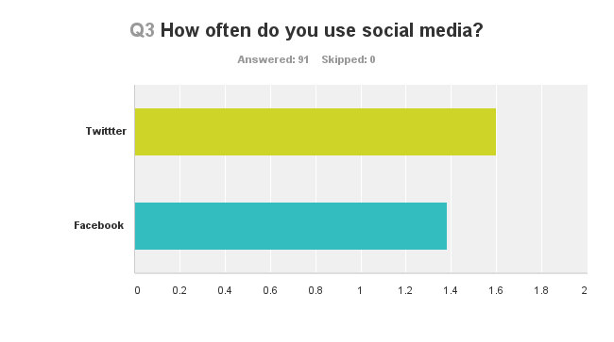
Figure 1
The study also observed political activity on social media. Participants were asked to record personal exposure to politics on SNS. Based on the same one to six scale from the previous question, the mean was 5.6. The results consisted of 79.12 percent of respondents claiming that they saw multiple posts a day. An additional 10.99 percent said that they saw one post a day, and 9.9 percent saw less than one a day. This shows that a number of politically active social media users are noticeably visible today.
The two political parties responded similarly in terms of positive and negative posts for political parties. Democrats and Republicans both saw a fair amount of positive exposure for the Democratic Party. As seen in Figure 2, 46.15 percent said that they saw positive or mostly positive posts for the Democrats, but 29.67 claimed to see more neutral posts, and 24.18 percent said that the posts were negative or mostly negative. In contrast, Democrats and Republicans alike saw more negativity toward the Republican Party on SNS. The statistics are as follows: 5.75 saw mostly positive/ positive posts, 20.69 saw fairly neutral posts, and 73.56 saw mostly negative or negative posts. On a one to five scale (one being negative and five being positive) the average for Democrats was 3.3, and for Republicans, 2.15. The standard deviation was .764. This shows that the spread of responses was very slim. All in all, these results show that the Republican Party has a significantly more negative representation on social media.
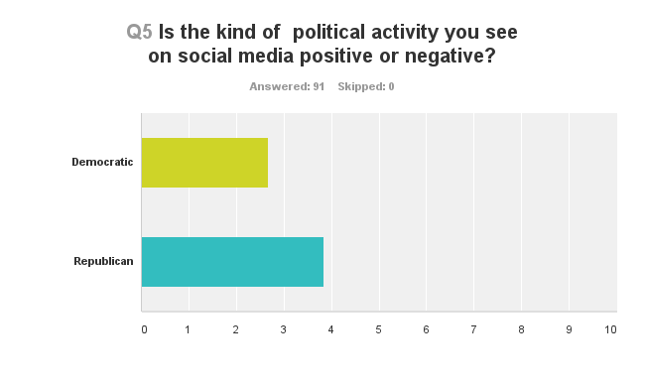
Figure 2
Statistics showed that political activity on social media was more likely to have an effect on those who are Democrats. Of the participants who identified as Democrats, 50 percent agreed that political activity on social media has an effect on their political views. 58.33 percent agreed that seeing political activity on social media has made them more politically active, and 61.11 percent subsequently agreed that social media has affected their support for a specific candidate. On a one to five scale, where one was strongly agree and five was strongly disagree, the average Democratic response for political activity on social media affecting their political views was 2.69. Meanwhile, the average for increased political activity after seeing political activity on social media was 2.56. Lastly, the average for political activity on social media affecting the respondents’ support for a specific candidate was 2.42.
Once again, in contrast, participants who identified as Republican self-reported themselves to be less likely to be affected by political activity on social media. As such, 50 percent did not agree that social media has an effect on their political views. Additionally, 59.1 percent said that political activity has not made them more politically active. Finally, 50 percent said that political activity on social media has not persuaded them to support a specific candidate. On the same one to five scale featured for the Democrats, Republicans responded with a mean of 3.55 for political activity on social media affecting their political views. Additionally, the average for increased political activity after seeing political activity on social media was 3.41. Finally, the average for political activity on social media affecting the respondents’ support for a specific candidate was 3.45. Therefore, this further displays that Republicans are less likely to be influenced by political activity on social media.
According to the survey results, there appears to be a discrepancy between Twitter and Facebook use and the influence each has. In regards to the correlation data, people are more likely to see more political activity if they use Facebook multiple times a day than if they use Twitter multiple times a day. Despite seeing more political activity on Facebook, data showed a higher correlation between Twitter use and influence than Facebook use and influence among respondents. As for, political activity on social media affecting participants’ political views, the Pearson correlation to Twitter use was .300, while the Pearson Correlation to Facebook use was only .028. The Pearson Correlation between becoming more politically active after seeing political activity and Twitter use was 3.77, and Facebook use was .110. In regards to the Pearson Correlation between support of a specific candidate based on political activity on social media and Twitter use, the Pearson Correlation was .263. In turn, the correlation for Facebook use was .004. In further analyzing the survey data, the strongest correlation was between how social media affects views and candidate support. The Pearson Correlation between these two was .799.
Conclusion:
This study resulted in several statistical findings. Notably, the content of political activity on social media is perceived as more influential when positive. The survey showed that participants saw more positive posts for Democrats than they did for Republicans. Democratic respondents reported being influenced more by what they see on social media than the Republican respondents. That shows that people are more susceptible to things that support what they already believe. As such, when a Democrat sees positive democratic posts on social media, that person is more likely to consider said positive views in their own political ideals. In contrast, if a Republican sees negative Republican posts on social media, then that individual is less likely to acknowledge those views. This split in perception creates a notable separation between Republican and Democratic voters in regards to the effectiveness of political activity on social media.
The effectiveness of political activity on social media varies between the two major political parties. Of the participants who were Democrat, half agreed that the political activity they witnessed on SNS influenced their beliefs. Additionally, more of these participants agreed that political activity on social media has increased their own political activity. This shows that political activity online does, in fact, impact political activity for Democrats. Corresponding with this activity, Democrats were visibly more inclined to support a specific candidate based on what they see SNS. Republicans, however, showed an unwillingness to change their beliefs based on the political activity they viewed on social media. The political activity on social media also lacked substantial effect on a Republican’s own political activity. Therefore, Republicans were not likely to support a specific candidate based on what they see on social media. These results continue to support the fact that Democrats are more easily influenced by political activity on social media.
The influence of each social media site varies drastically compared to the amount of political activity visible on each site. The survey showed that people see more political activity on Facebook than on Twitter, even if only slightly. Despite this, participants reported being more influenced by political activity they see on Twitter than political activity they see on Facebook. The Pearson Correlations between high Twitter use and the influence of political activity on social media were high, while the Pearson Correlation between high Facebook use and the influence of political activity on social media was much lower. This shows that the participants in this study are more influenced by what they see on Twitter than what they see on Facebook. Thus suggesting that political activity on Twitter is taken more seriously than political activity on Facebook. That means that, at least among the participants in this study, Twitter is a more effective medium to convey information to people than Facebook is.
As for the Pearson Correlation between support of a specific candidate based on political activity on social media and social media use, Twitter displayed a strong correlation. Facebook’s Pearson Correlation was notably weaker. On Twitter, participants viewed candidates as more influential. Subsequently, Twitter’s effect on views directly correlates with its effect on candidate support. Meanwhile, Facebook has far less of an impact on candidate support. In sum, Twitter has the potential to provide a strong foundation for candidate support.
To conclude, according to this survey, the most effective method of gaining support would be campaigning on Twitter. Additionally, social media clearly impacts Democrats more than Republicans. This makes them far more susceptible to social media campaigns. Furthermore, political activity on social media is more influential when positive. In fact, negative activity discourages political activity among young voters. These results display clear points of interest between the positive correlations within social media and political activity.

Works Cited
Bode, L., Vraga, E. K., Borah, P., & Shah, D. V. (2014). A new space for political behavior: Political social networking and its democratic consequences. Journal of computer- mediated communication, 19(3), 414-429.
Chia-Shin Lin, L. (2015). Facebook politics: Strategic network campaigning in the 2012 Taiwan presidential election. Media international Australia incorporating culture and policy, 155, 54-65.
Dumitrica, D. (2016). Imagining engagement: Youth, social media, and electoral processes. Convergence: The journal of research into new media technologies, 35-53.
Jung, N., & Valenzuela, S. (2012). Social media use for news and individuals' social capital, civic engagement and political participation. Journal of computer-mediated communication, 319-336.
Martinez-Rolan, X., & Pineiro-Otero, T. (2016). The use of memes in the discourse of political parties on Twitter: analyzing the 2015 state of the nation debate. Communication & society, 145-159.
Park, C. (2015). Pathways to expressive and collective participation: Usage patterns, political efficacy, and political participation in social networking sites. Journal of broadcasting & electronic media, 698-716.
Segaard, S. B. (2015). Perceptions of social media: A joint arena for voters and politicians? Nordicom review, 36(2), 65-78.

Storsul, T. (2014). Deliberation or self-presentation?: Young people, politics and social media. Nordicom review, 35(2), 17-28.

Velasquez, A., & Larose, R. (2014). Youth collective activism through social media: The role of collective efficacy. New media & society, 17(6), 899-918.

Wicks, R. H., Wicks, J. L., Morimoto, S. A., Maxwell, A., & Schulte, S. R. (2013). Correlates of political and civic engagement among youth during the 2012 presidential campaign. American behavioral scientist, 58(5), 622-644.

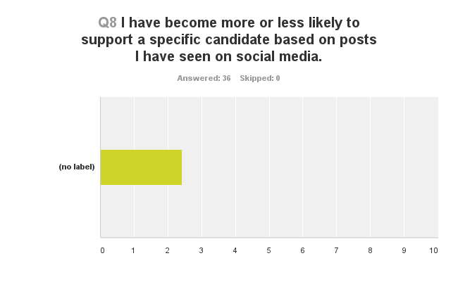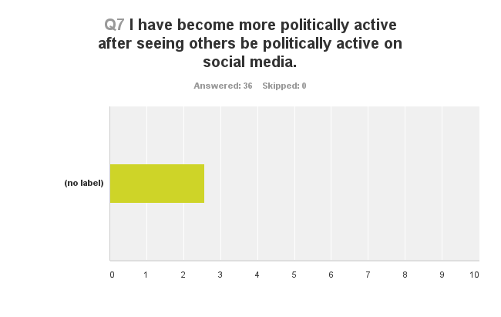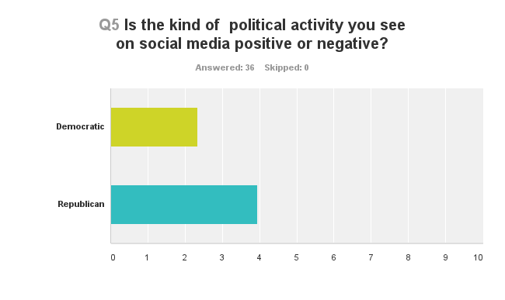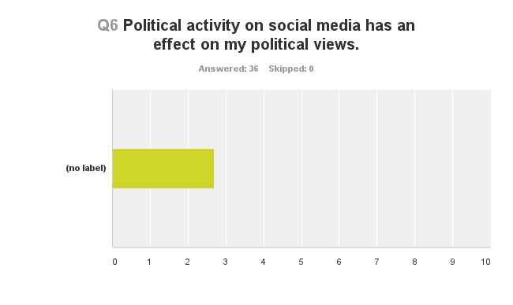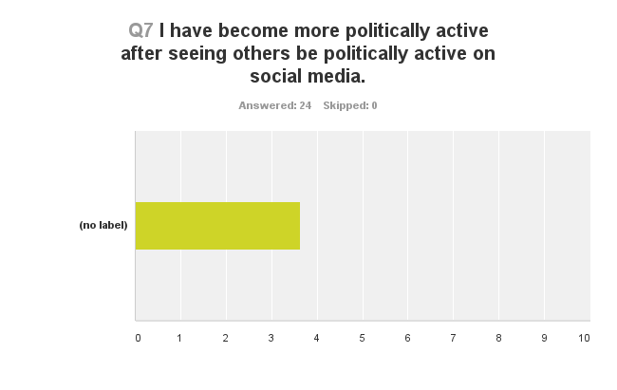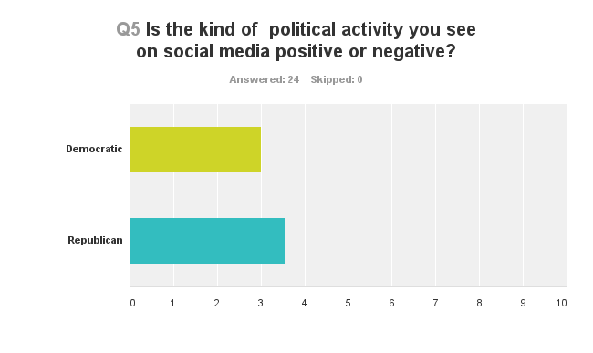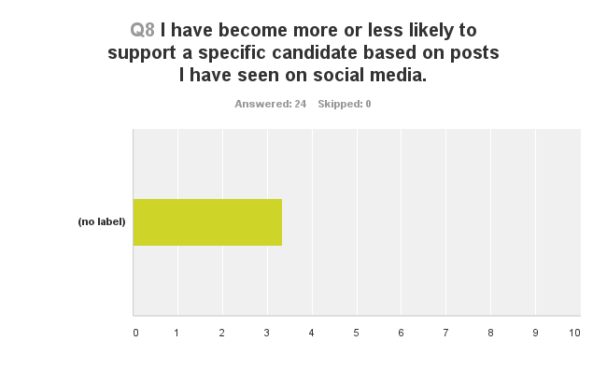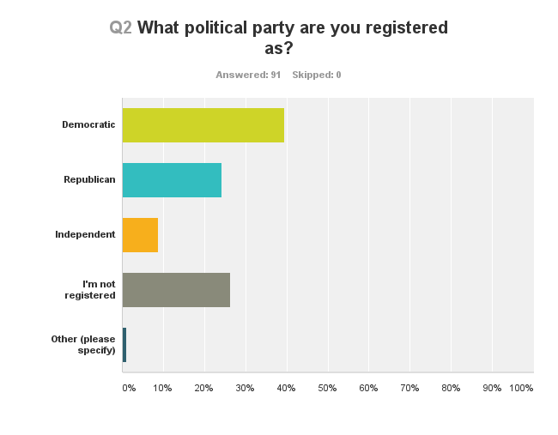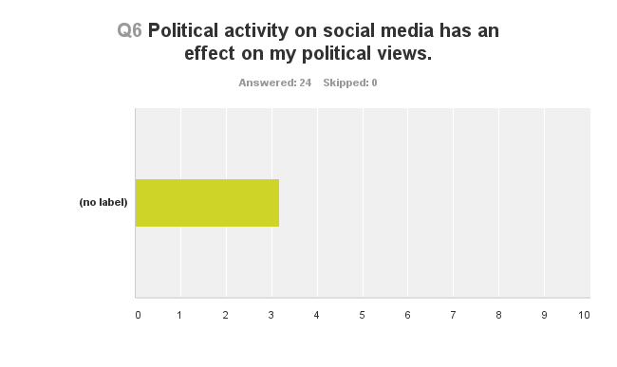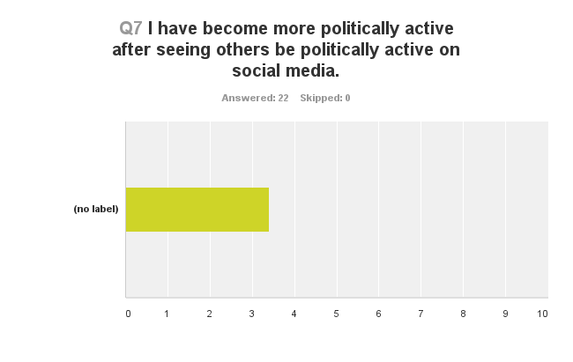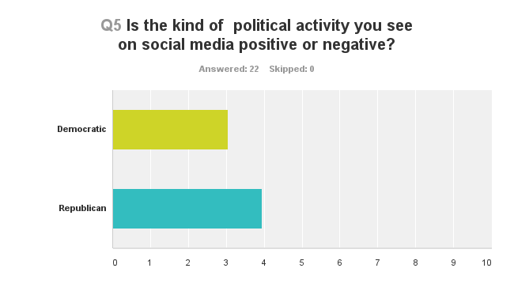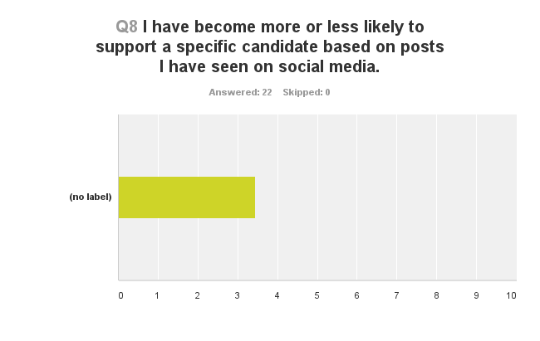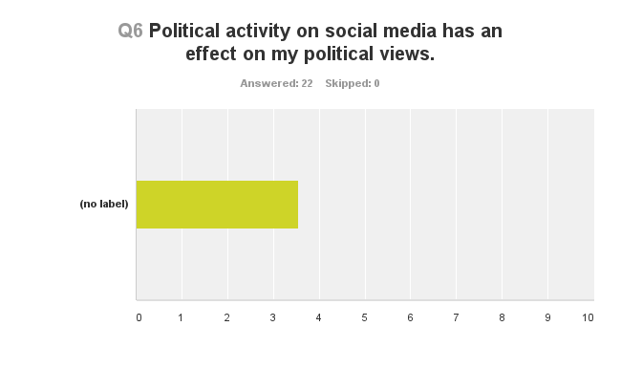
Figure 3
Figure 4
Figure 5
Figure 6
Figure 7
Figure 8
Figure 9
Figure 10
Figure 11
Figure 12
Figure 13
Figure 14
Figure 15
Figure 16

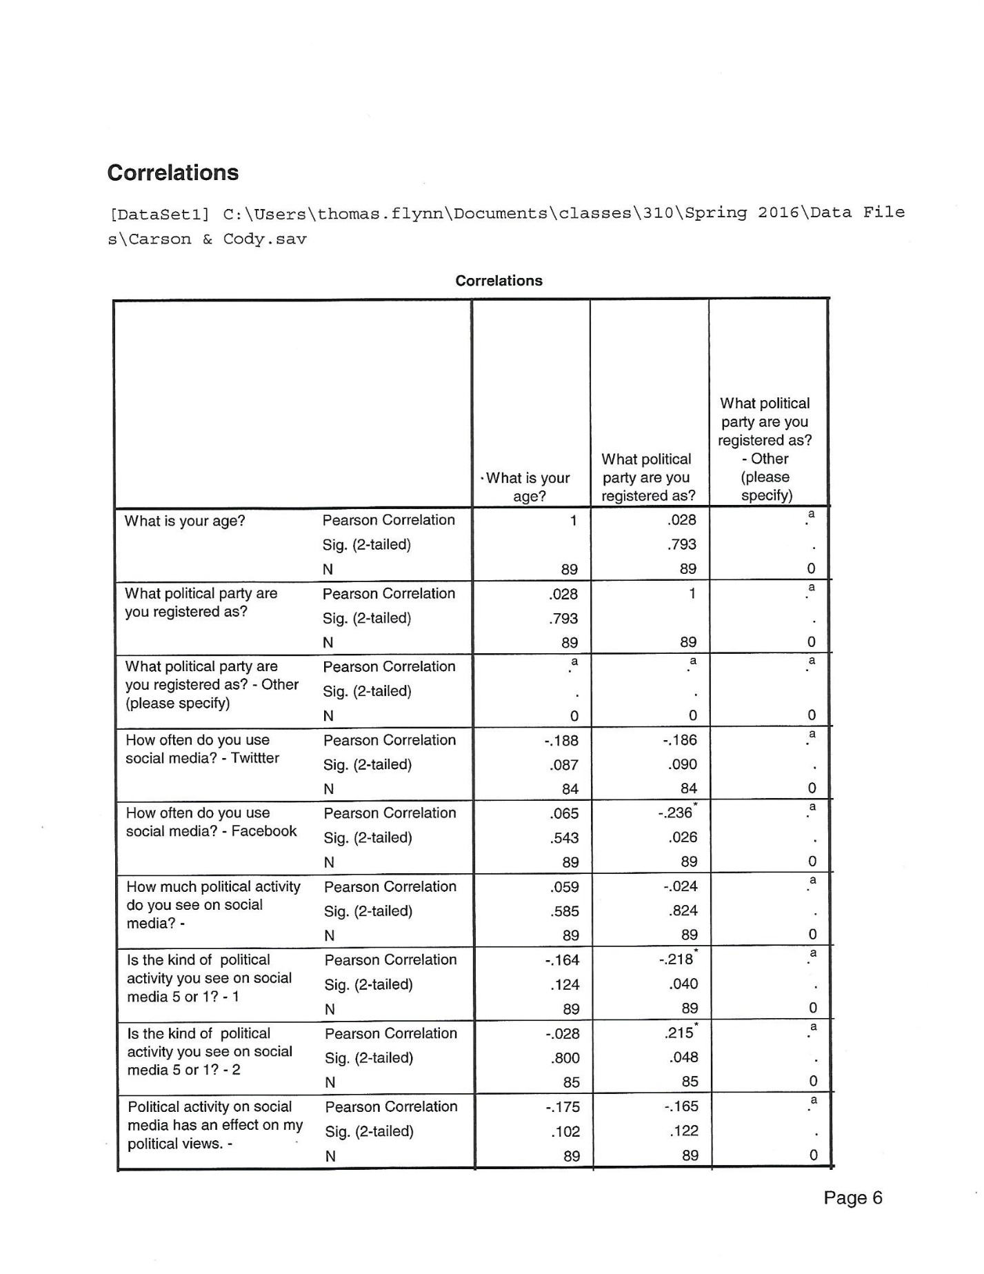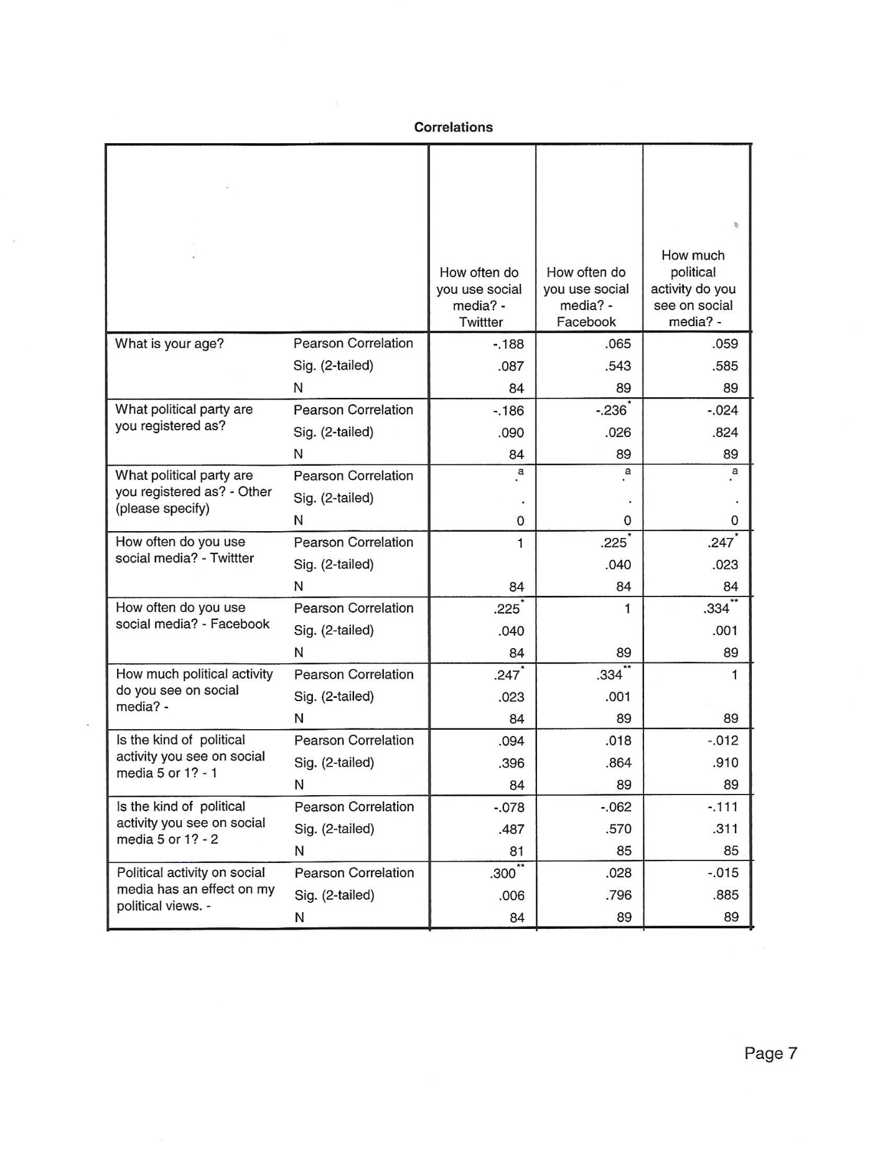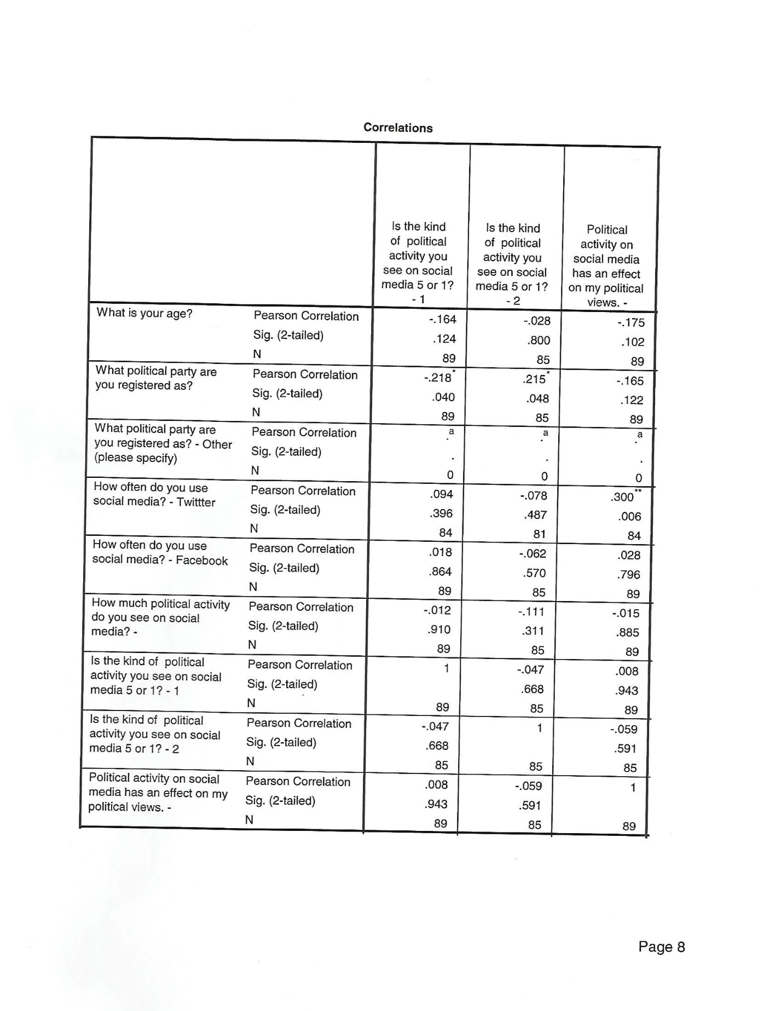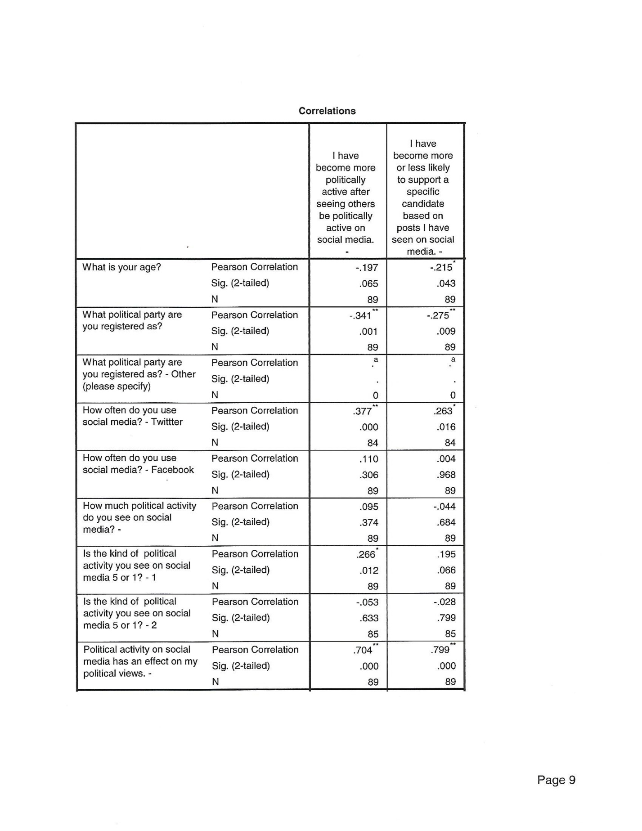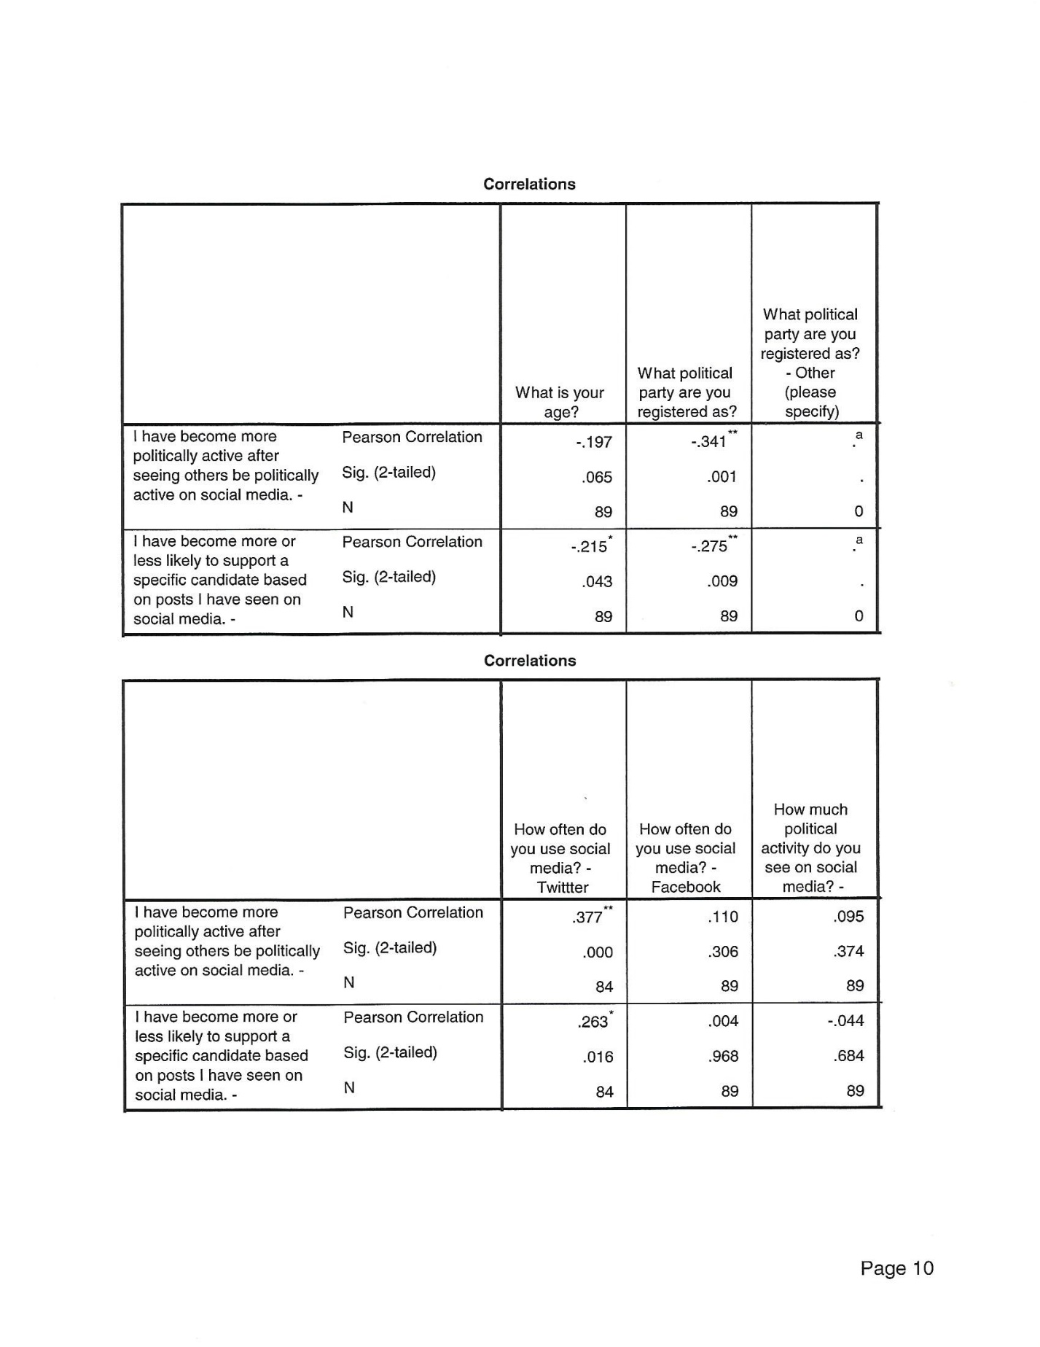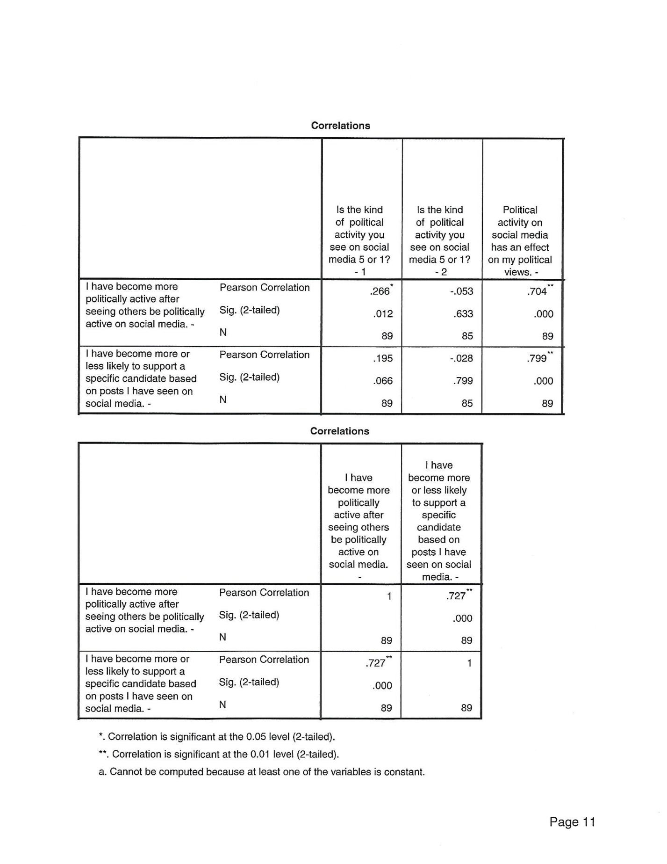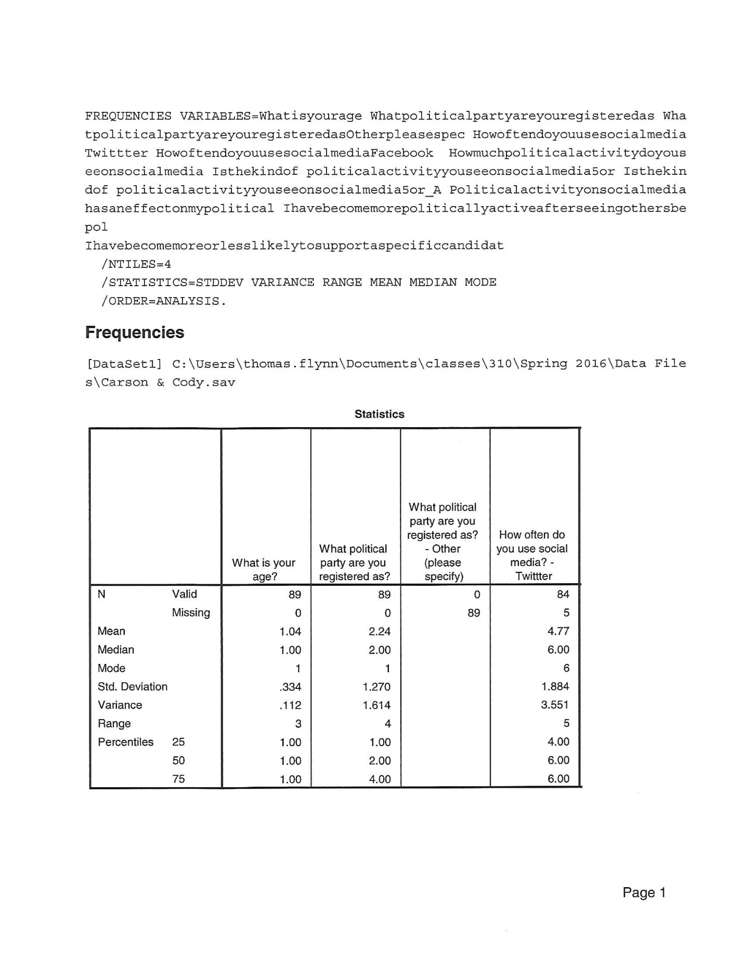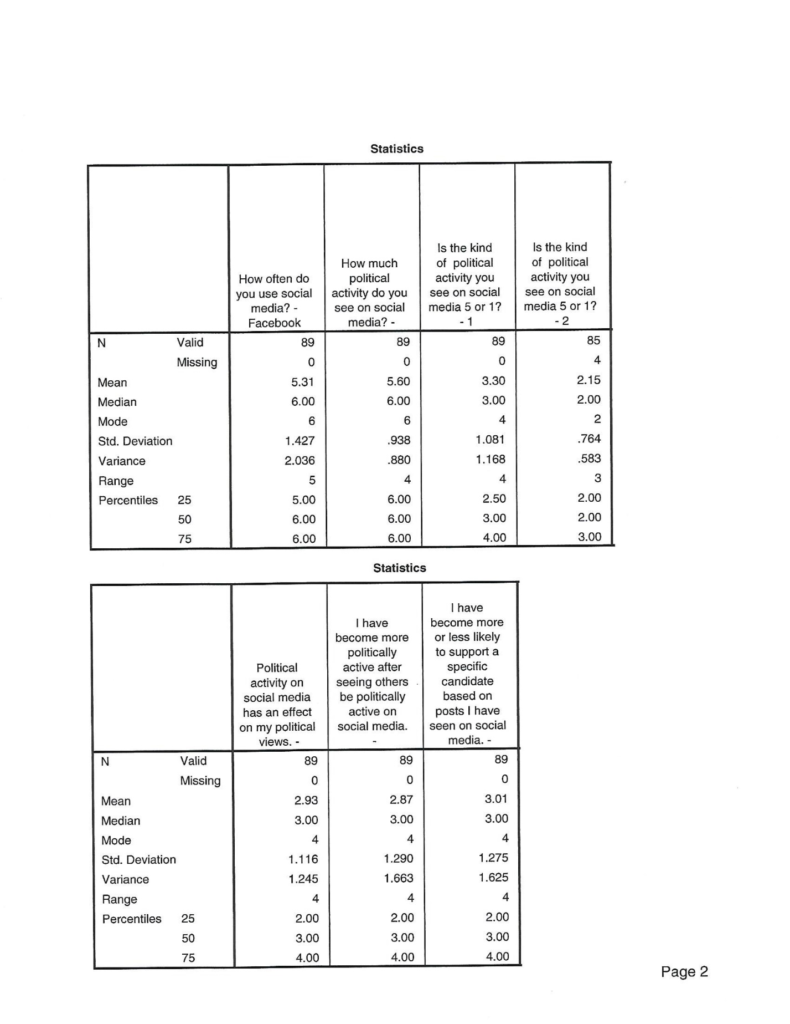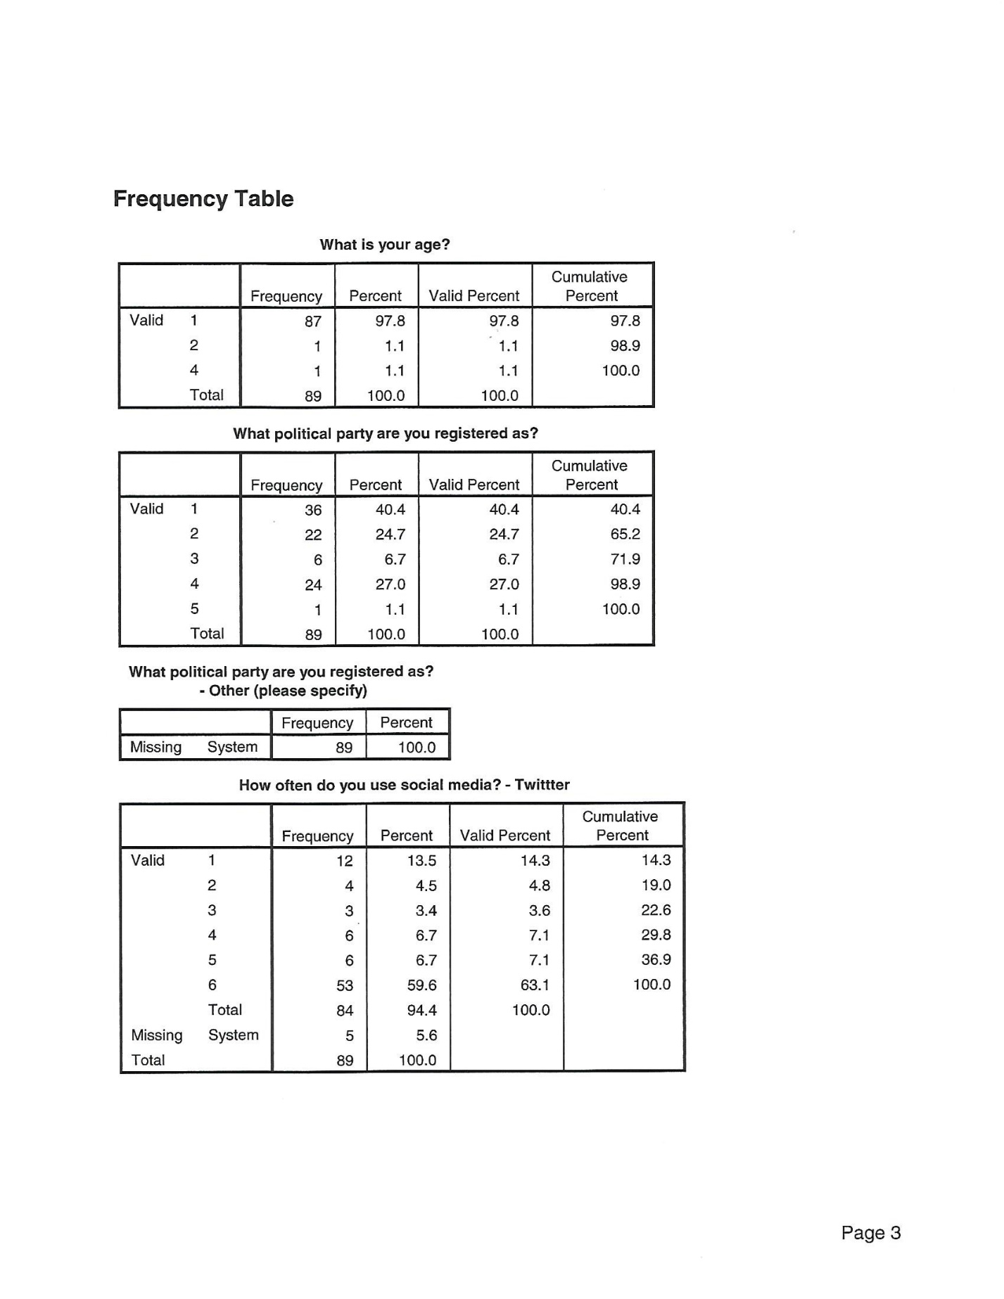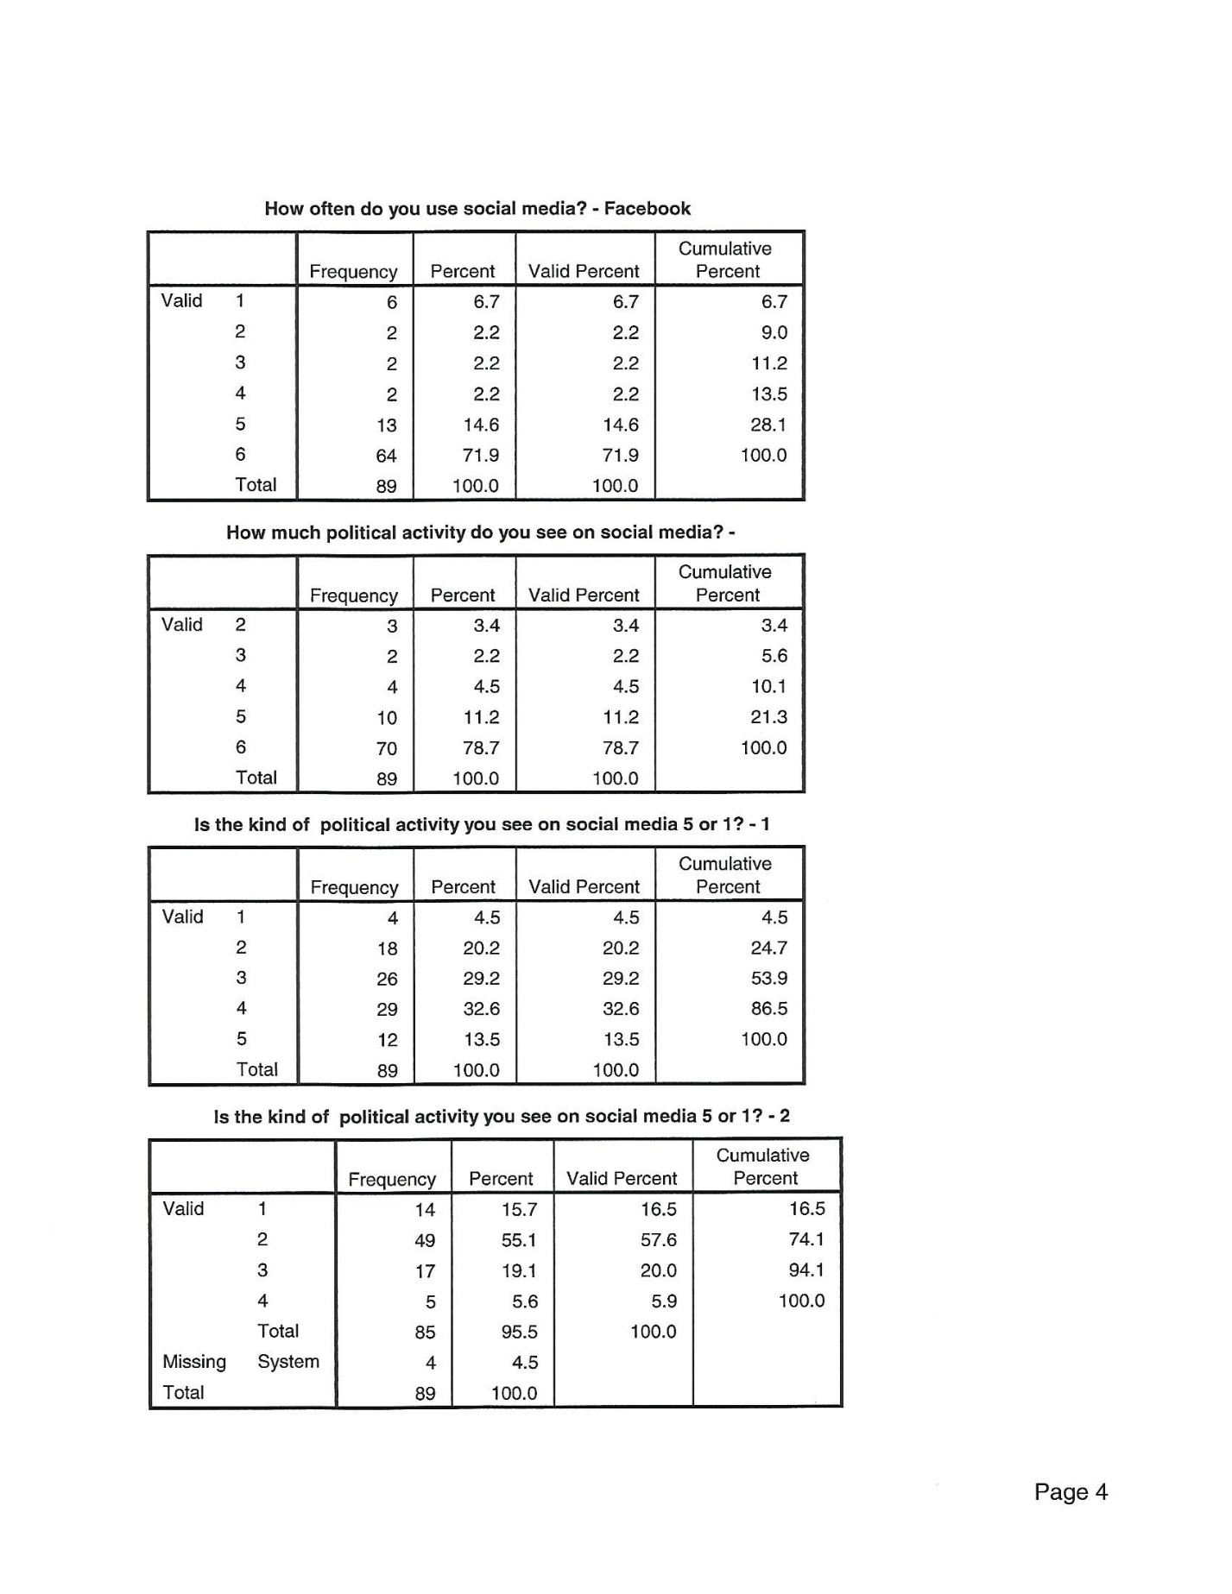
Figure 17
Figure 18
Figure 19
Figure 20
Figure 21
Figure 22
Figure 23
Figure 24
Figure 25
Figure 26
Figure 27

